Tips on Finding Bed Bugs
If you have an infestation or spot signs of concern notify management right away per your agency protocol. It is always best to find it in infestation early, before it becomes established or spreads. Treating a minor infestation, while an inconvenience, is far less costly and easier than treating the same infestation after it becomes more widespread.
However, low-level infestations are also much more challenging to find and correctly identify. Other insects, such as carpet beetles, can be easily mistaken for bed bugs. If you misidentify a bed bug infestation, it gives the bugs more time to spread to other areas of the house or hitchhike a ride to someone else's house to start a new infestation. Learn about identifying bed bugs.
Signs of Bed Bugs
- Bites on the skin are a poor indicator of a bed bug infestation. Bed bug bites can look like bites from other insects (such as mosquitoes or chiggers), rashes (such as eczema or fungal infections), or even hives. Some people do not react to bed bug bites at all.
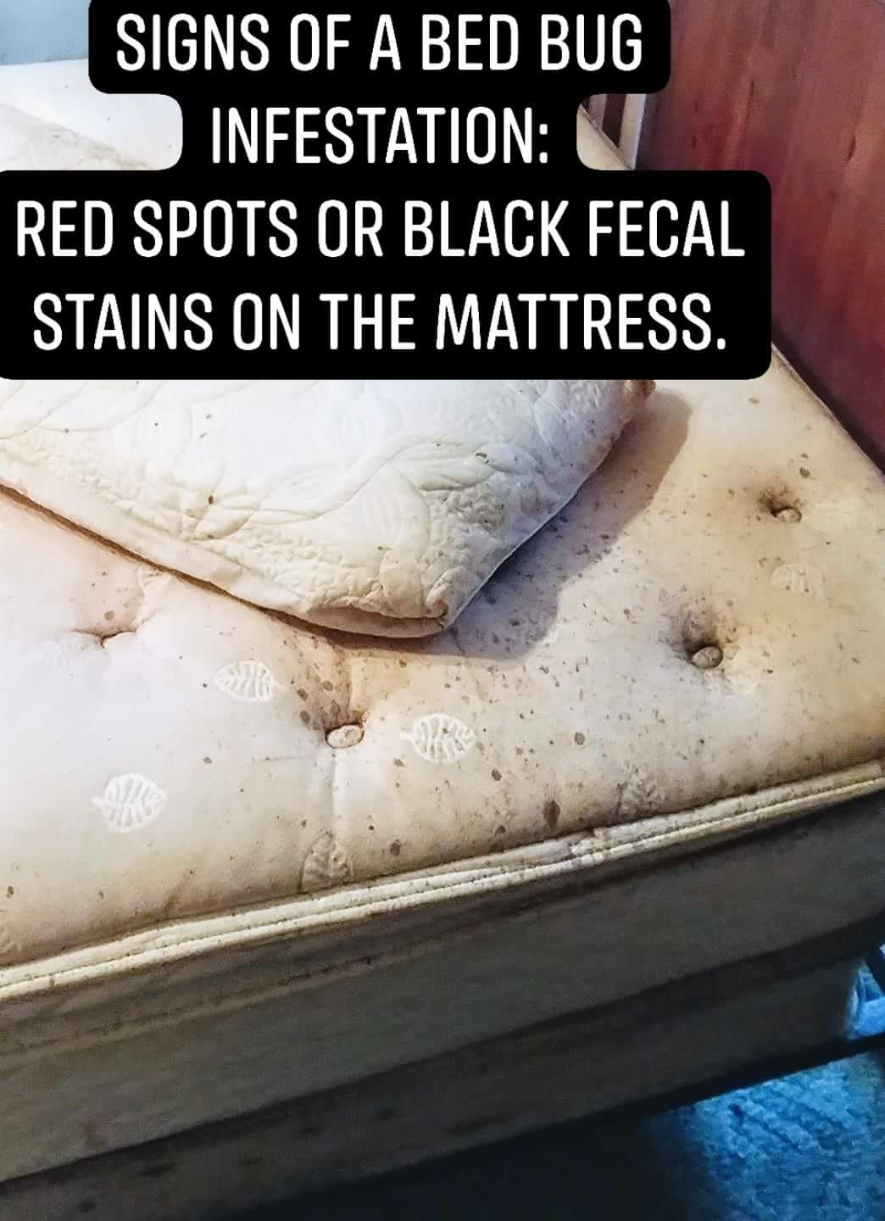
- Rusty or reddish stains on bed sheets or mattresses caused by bed bugs being crushed.
Dark spots are bed bug excrement or fecal blood and may bleed on the fabric like a marker would.

- Eggs and eggshells, which are tiny (about 1mm) and pale yellow skins that nymphs shed as they grow larger.

- Live Bed Bugs
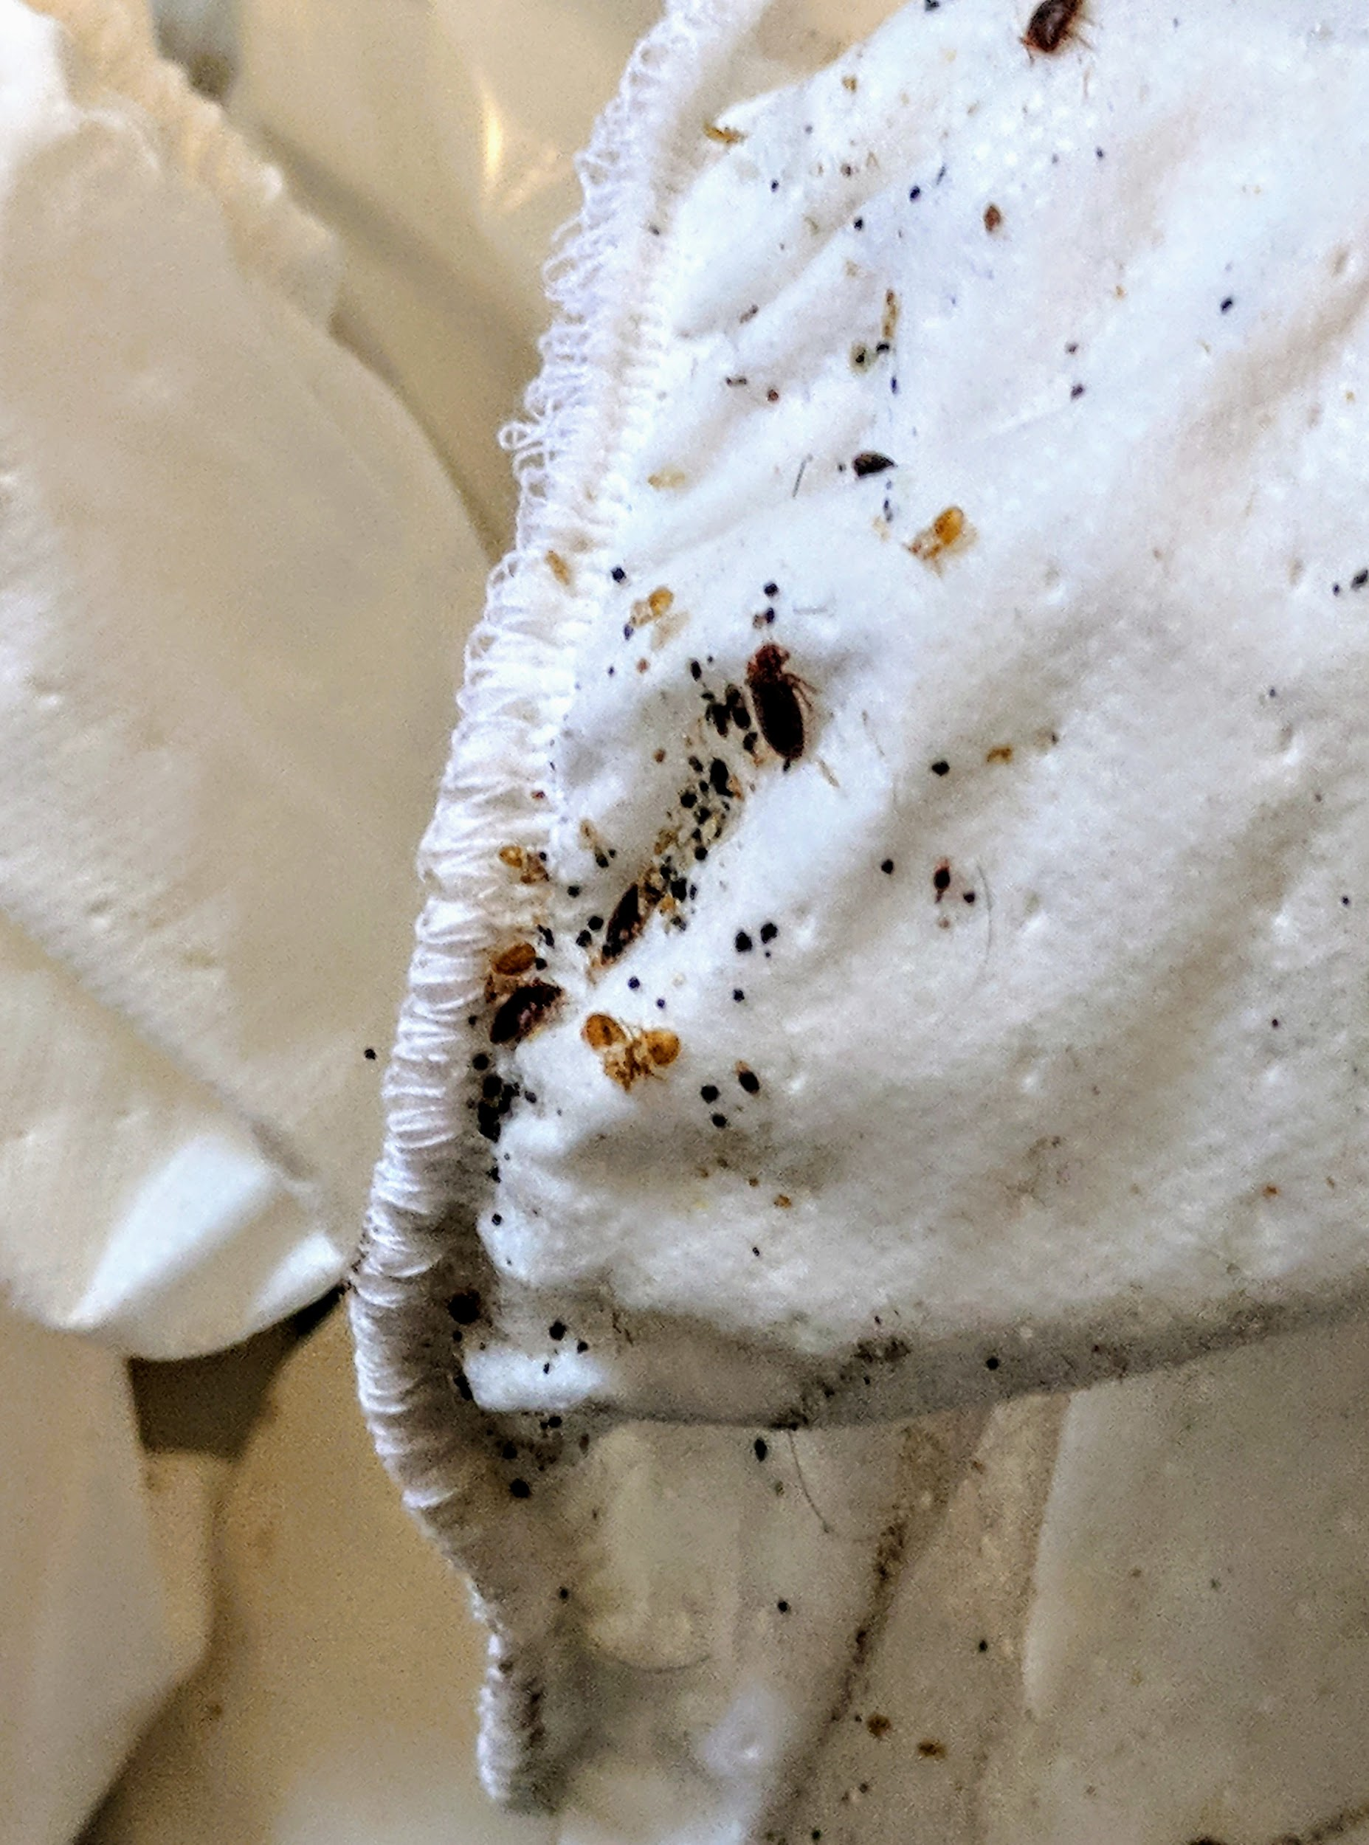

Where Bed Bugs Hide
Bed bug adults, skin castings, feces, eggs on a box spring.
Canvas strap of old box spring covering that is housing adults, skin castings, feces, and eggs.
When not feeding, bed bugs hide in a variety of places. Around the bed, they can be found near the baseboards, seams and tags of the mattress and box spring, and in cracks on the bed frame and headboard.
If the room is heavily infested, you may find bed bugs:
In the seams of chairs and couches, between cushions, in the folds of curtains.
In dresser drawer joints.
In electrical receptacles and appliances. It is recommended to cover outlets with safety covers.
Under loose wall paper and wall hangings.
At the junction where the wall and the ceiling meet.
Since bed bugs are only about the width of a credit card, they can squeeze into really small hiding spots. If a crack will hold a credit card, it could hide a bed bug.

It is important to vacuum residence on a weekly basis. Any live or dead bed bugs found are to be vacuumed and disposed of in an outdoor trash immediately.
Dry all bedding, clothing, and plush items in the infested residence at the highest heat for 30 minutes. Also, follow this process with all personal items when returning home from a known bed bug infestation or residence recently cleared or at a high risk for bed bug infestation. PROTECT YOUR HOME!
Bed bugs are found almost anywhere their host can live, so are typically found in regularly used furniture and headboards of normal sleeping areas!

These regularly utilized items need inspected on a monthly basis with staff assistance.
- You can see the white bed bug eggs in the crevice of an infested headboard here:
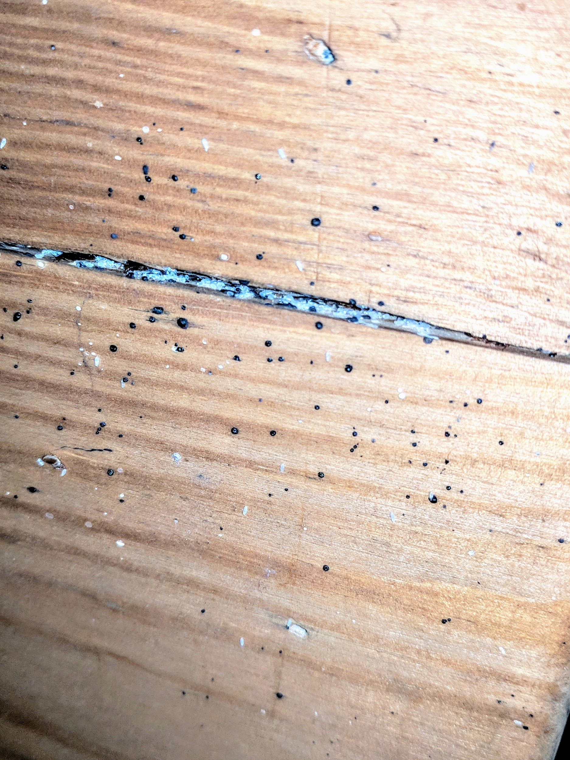

QUESTIONS TO ADDRESS
- Prep

- Expectations after treatment

- Steps after treatment : vacuum, cleaning, how long to leave dust down…

- Signs of concerns : when & how to contact management

- How often to inspect

- Prevention Tips

- Reintroduction Tips

